Postal Life Insurance

Department of Post

Software Requirements Specification (SRS)/ Functional Requirements Specification (FRS)
  - Agent Incentive, Commission and Producer Management

INTERNAL APPROVAL FORM

Project Name: Agent Incentive, Commission and Producer Management
Version: 1.0
Submitted on:
 | Name | Date
Approved By:
Reviewed By:
Prepared By:

VERSION CONTROL LOG
Version | Date | Prepared By | Remarks
1

Table of Contents

1. Executive Summary 4
2. Project Scope 4
3. Business Requirements 4
4. Functional Requirements Specification 6
4.1 Agent Onboarding 6
4.1.1 New Profile Options 6
4.1.2 Enter Profile Details Page 6
4.1.3 Select New Advisor Coordinator Page 8
4.2 Agent Profile Management 8
4.2.1 Agent Search 8
4.2.2 Agent Profile Maintenance Page 9
4.2.3 License Management Page 10
4.2.3 Agent Termination Page 10
4.3 Agent Commission Management 11
4.3.1 Commission Rate Table View Page 11
4.3.2 Commission History Search Page 11
4.3.3 Commission Processing Steps: 11
5. Appendices 15

1. Executive Summary
To provide the functional and non-functional requirements for developing an Agent Onboarding & Commission Management System similar to PMACS for India Post PLI. The system will support onboarding and administration of Agents, Advisor Coordinators, Field Officers, and Departmental Employees; manage licensing and status lifecycle; and calculate, approve, and disburse commissions.

2. Project Scope
This system will support:
- Agent onboarding (Advisor, Coordinator, Field Officer, Departmental Employee)
- Agent profile management
- Commission rate setup and processing
- Trail and Final Incentive statement generation and disbursement
- Licensing and termination workflows

3. Business Requirements
Requirement ID | Functionality | Requirement
FS_IC_001 | Agent Onboarding | The system shall allow creation of a new Advisor profile, which must be linked to an existing Advisor Coordinator already present in the system.
FS_IC_002 |  | The system shall support creation of a new Advisor Coordinator profile, including assignment to a specific circle and division.
FS_IC_003 |  | The system shall enable onboarding of Departmental Employees by auto-populating profile data using a valid Employee ID from the HRMS system.
FS_IC_004 |  | The system shall allow onboarding of Field Officers either by auto-fetching data using Employee ID or through manual entry.
FS_IC_005 | Agent Profile Management | The system shall provide a search interface to locate agent profiles using Agent ID, Name, PAN, or Mobile Number.
FS_IC_006 |  | The system shall display a dashboard view of the agent profile with editable sections for each data category.
FS_IC_007 |  | The system shall allow authorized users to update the agent’s name with proper validation and audit logging.
FS_IC_008 |  | The system shall allow updating of PAN information with format validation and uniqueness checks.
FS_IC_009 |  | The system shall support status updates for agents (e.g., Active, Suspended, Terminated) along with mandatory reason entry.
FS_IC_010 |  | The system shall allow updating of personal information including date of birth, gender, and marital status.
FS_IC_011 |  | The system shall support addition and modification of distribution channel details with effective dates.
FS_IC_012 |  | The system shall allow entry and update of external identification numbers and their sources.
FS_IC_013 |  | The system shall support assignment and modification of product class information linked to the agent.
FS_IC_014 |  | The system shall allow entry and update of multiple address types: Official, Permanent, and Communication.
FS_IC_015 |  | The system shall support entry and update of phone numbers including official/resident landline and mobile numbers.
FS_IC_016 |  | The system shall allow entry and update of email addresses categorized as official, permanent, and communication.
FS_IC_017 |  | The system shall support assignment of authority types and validity periods for agents.
FS_IC_018 |  | The system shall allow entry and update of insurance licensing details and generate automated reminders at 1 month, 15 days, 7 days, and on the day of expiry.
FS_IC_019 |  | The system shall enforce license renewal rules: first renewal after 1 year, subsequent renewals every 3 years.
FS_IC_020 |  | The system shall automatically deactivate an advisor code if the license renewal date has elapsed, or allow manual cancellation via the License Update Entry page.
FS_IC_021 | Advisor Termination | The system shall allow termination of an advisor profile with mandatory entry of termination reason and effective date.
FS_IC_022 | Commission Processing | The system shall provide a Commission Rate Table setup interface with fields for Rate, Policy Duration (Months), Product Type, Product Plan Code, Agent Type, and Policy Term (Years).
FS_IC_023 |  | The system shall allow searching of commission history by policy number and agent ID.
FS_IC_024 |  | The system shall support execution of monthly Commission Calculation Batch jobs to compute agent commissions.
FS_IC_025 |  | The system shall support automatic generation of Trial Statements via batch job based on policies sold.
FS_IC_026 |  | The system shall provide a page to view generated Trial Statements with agent-wise commission details.
FS_IC_027 |  | The system shall provide a Manual Trial Statement Generation page with fields for Processing Unit, Statement Format, Max Statement Due Date, Max Transaction Effective Date, Max Process Date, Statement Date, Contract Holder, Advisor Coordinator, and Carrier.
FS_IC_028 |  | The system shall provide an Approving Trial Statement page that displays commission amounts and allows full or partial disbursement approval.
FS_IC_029 |  | The system shall support execution of Final Incentive Statement Generation batch job after trial statement approval.
FS_IC_030 |  | The system shall provide a Final Statements page displaying final commission amounts for agents.
FS_IC_031 |  | The system shall provide a Disbursement Details page to input cheque or EFT information.
FS_IC_032 |  | The system shall support automatic disbursement of commission amounts based on final statements, with immediate processing for cheque and queued processing for EFT.

4. Functional Requirements Specification

4.1 Agent Onboarding

4.1.1 New Profile Options
- Purpose: To select the type of Agent that needs to be onboarded.
- Fields & Rules:
  - Agent Type: dropdown: Options are Advisor, Advisor Coordinator, Departmental Employee, Field Officer
  - Employee Number: Textbox: Mandatory for Departmental Employee, optional for Field Officer, Not Applicable for others.
  - Person Type: Dropdown: Options are Individual, Corporate/Group.
  - Advisor Undergoing Training: Checkbox: Default Unchecked
  - Continue: button

4.1.2 Enter Profile Details Page
- Purpose: This page will get displayed after selecting new profile options and clicking continue button.
- Fields & Rules:
  - Profile Type: Dropdown
  - Office Type: Dropdown
  - Office Code: Textbox
  - Advisor Sub-Type: Dropdown
  - Effective Date: Calendar
  - Distribution Channel: Multiselect Dropdown: Options are India Post.
  - Product Class: Multiselect Dropdown: Options are PLI, RPLI
  - Title: Dropdown
  - First Name: Textbox
  - Middle Name: Textbox
  - Last Name: Textbox
  - Gender: Dropdown: Options are Male, Female, Other
  - Date of Birth: Calendar
  - Category: Dropdown
  - Marital Status: Dropdown
  - Aadhar Number: Textbox
  - PAN: Textbox
  - Designation/Rank: Dropdown
  - Service Number: Textbox
  - Professional Title: Dropdown
  - Address:
    - Address Type: Dropdown: Options as Official, Permanent, Communication.
    - Address Line1-
    - Address Line2-
    - Village-
    - Taluka-
    - City-
    - District-
    - State-
    - Country-
    - Pin Code-
  - Phone:
  - Email:
  - Bank Account#:
  - Bank IFSC Code:
  - Superior Advisor: This will open Select New Advisor Coordinator Page, and the user will return to this page after selection of advisors.
  - Office Affiliation: Textbox: Input Affiliated Office Code
Serial Number | Condition | Error Message | Required Action
1 | If the Profile type is not selected and Continue button is pressed. | Please select a Profile Type. | Users must select the Profile Type from the drop-down list.
2 | If the PAN number entered already exists for some other profile. | PAN number entered already exists for another advisor’s profile and cannot be for this profile. | Users must enter the PAN number which does not exist for another advisor’s profile.
3 | PAN number should be of 10 characters. If the PAN number length doesn’t match. | Please enter a 10 digit Permanent Account Number (PAN). | Users must enter the 10 digit PAN number.
4 | PAN number should be entered in the standard format as shown above. If the PAN doesn’t match with the format as already defined in the system. | Please enter correct PAN. | Users must enter the PAN number as per the standard format.
5 | If the Last name is not entered and Continue button is pressed. | Please enter a Last name. | Users must enter the last name of the Advisor.
6 | If the First name is not entered and Continue button is pressed. | Please enter a First name. | Users must enter the first name of the Advisor.
7 | If the Date of Birth is not entered and Continue button is pressed. | Please enter a valid Date of Birth | Users must enter the valid Date Of Birth.

4.1.3 Select New Advisor Coordinator Page
- Purpose: If the new profile reports to an Advisor Coordinator already present in system, then select Agent type as ‘Advisor’ and click the Continue button to move the user to the Select New Advisor Coordinator page.
- Fields & Rules:
  - AC Profile#: text box
  - AC Profile Name: text box
  - Search: button
- Clicking the search button should display the following table with auto-populated agent details:
  - AC Profile#
  - AC Profile Name
  - Profile Type
  - Status
  - Person: Individual or Corporate/Group
  - Action: Link for selecting the Advisor Coordinator
Serial Number | Error Message | Required Action
1 | Your selected criteria did not return any rows. Please change your selections and try again. | Users must change the selection

4.2 Agent Profile Management

4.2.1 Agent Search
- Purpose: To search an Existing Agent for performing some action like View / Edit / Terminate / Suspend / viewing Commission History.
- Fields:
  - Agent ID: Textbox
  - Last Name: Textbox
  - First Name: Textbox
  - PAN: Textbox
  - Mobile Number: Textbox
  - Status: Textbox
  - Superior Advisor Code: Textbox
  - Office ID: Textbox
  - Advisor Undergoing Training: Checkbox
  - Search: button
- Business Rules:
  - Results displayed in a table with clickable rows.
  - Clicking on any Agent in table will open that Agent Profile Maintenance Page for that agent.
  - ‘Export to Excel’ option should be present for the table details to be exported in excel format.

4.2.2 Agent Profile Maintenance Page
- Purpose: Displays agent details with option to edit each section.
- Fields & Rules: It should display all the information about the agent with ‘Update’ link in each section to update the details of that section. The sections that need to be displayed are:
  - Advisor Name Section
  - PAN Number Information
  - Status Information: Add additional ‘Change Status To’ dropdown for updating the Agent Status to Expired/Suspended/ Terminated.
  - Personal Information
  - Distribution Channel
  - External Number
  - Product Class
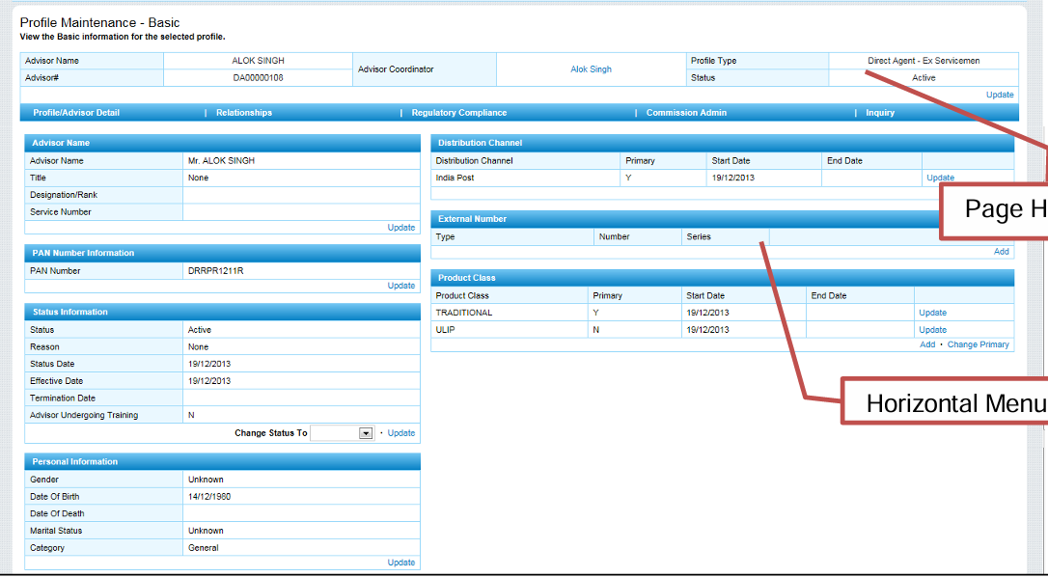

4.2.3 License Management Page
- Purpose: This page will display the list of licenses the current agent have along with the option to Add or Delete License.
- Fields:
  - License Line: Dropdown: Option as Life
  - License Type: Dropdown
  - License Number: Textbox
  - Resident Status: Dropdown: Option as Resident, Non-Resident
  - License Date: Calendar
  - Renewal Date: Calendar
  - Authority Date: Calendar
  - Submit: Button
  - Update Renewal Date: Button
  - Delete License: Button
- Business Rules:
  - First License Renewal notice will be generated for the license renewal 1 month before the License expiry date.
  - Second License Renewal notice will be generated for the license renewal 15 days before the License expiry date, if not renewed already.
  - Third License Renewal notice will be generated for the license renewal 7 days before the License expiry date, if not renewed already.
  - Final License Renewal notice will be generated for the license renewal on the License expiry date, if not renewed already.

4.2.3 Agent Termination Page
- Search an Agent.
- Move to ‘Agent Profile Maintenance Page’ for the Agent.
- For terminating a profile, user needs to select the ‘Change Status To’ Dropdown in status section as Terminated and then click on Update. Agent Termination Page will open. Input the details and click submit to terminate the agent.
- Fields:
  - Status: dropdown
  - Status Reason: dropdown
  - Status Date: Calendar
  - Effective Date: Calendar
  - Termination Date: Calendar
  - Submit: Button

4.3 Agent Goal Setting
- Purpose: To set the performance goals for the Agents. The set goals should reflect in the agent profile in Agent Portal when the agent logins from his ID.
- Fields:
  - Agent ID: Text: Option should be given to search & select the agent.
  - Agent Name: Text: Auto-populated
  - Goal Period: From & To Dates from Calendar: To specify timeframe for the goal.
  - Target Number of Policies: Textbox: The number of new policies the agent aims to sell.
  - Target Premium Collection (₹): Textbox: The total premium amount expected to be collected.
  - Product-wise Targets: Textbox: Goals broken down by PLI/RPLI product types (e.g., Endowment, Whole Life).
  - Comments: Textbox
  - Submit: button

4.4 Agent Commission Management

4.4.1 Commission Rate Table View Page
- Purpose: To view the Defined commission rates based on multiple parameters.
- Fields: The page should display the following Commission table:
  - Rate (%): Decimal: Commission percentage
  - Policy Duration (Months): Integer: Duration of policy in months
  - Product Type: Dropdown: PLI, RPLI
  - Product Plan Code: Text: Unique code for the plan
  - Agent Type: Dropdown: e.g., Direct Agent, Field Officer
  - Policy Term (Years): Integer: Total term of the policy
- Action:
  - User should only view the table.

4.4.2 Commission History Search Page
- Purpose: View historical commission data.
- Search Filters:
  - Agent ID
  - Policy Number
  - Date Range
  - Product Type
  - Commission Type (First Year, Renewal, Bonus)
- Result Table:
  - | Agent ID | Policy Number | Product Type | Commission Type | Amount | Status | Date Processed |
- Actions:
  - Export to Excel/PDF
  - View Detailed Statement

4.4.3 Commission Processing Steps:
- Purpose: To generate and pay the commission for the Agents.
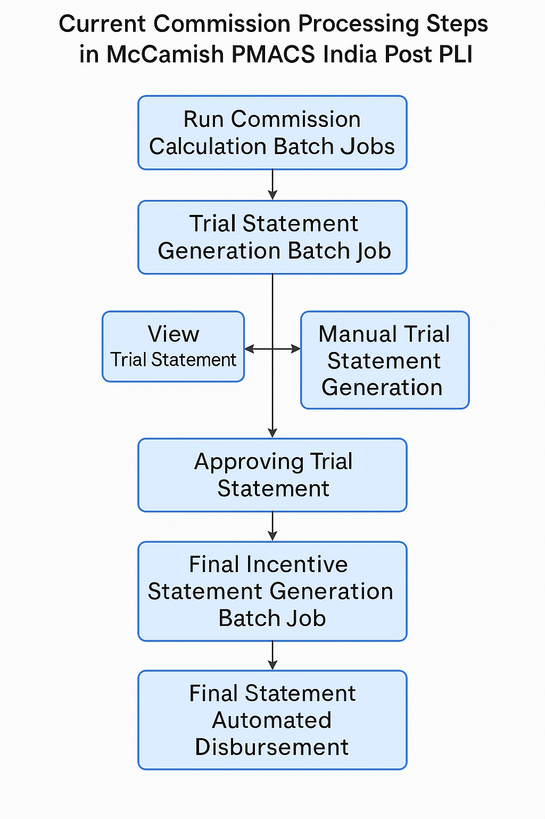

4.4.3.1 Run Commission Calculation Batch Jobs
- Trigger: Scheduled or Manual
- Function: Calculates Commission based on active policies and rate table.

4.4.3.2 Trial Statement Generation Batch Job
- Function: Generates trial commission statements for review.
- Output: Trial Statement per agent and policy.

4.4.3.3 View Trial Statement Page
- Fields:
  - Agent ID
  - Policy Number
  - Commission Type
  - Calculated Amount
  - Status (Pending/Approved)
  - Remarks
- Action:
  - Filter by Agent, Policy, Circle
  - Export to Excel/PDF
  - Raise Correction

4.4.3.4 Manual Trial Statement Generation Page
- Fields:
  - Processing Unit: Dropdown: e.g., IT2.0
  - Statement Format: Dropdown: e.g., Standard
  - Max Statement Due Date: Date: Cut-off for statement
  - Max Transaction Effective Date: Date: Latest transaction date
  - Max Process Date: Date: Latest processing date
  - Statement Date: Date: Date of statement
  - Contract Holder: Text: Name of policyholder
  - Advisor Coordinator: Text: Agent’s supervisor
  - Carrier: Text: Insurance carrier
  - Tax Deduction (TDS %): Decimal: Applicable tax deduction

- Action:
  - Generate Statement
  - Save Draft
  - Submit for Approval

4.4.3.5 Approving Trial Statement Page
- Fields:
  - Agent ID
  - Policy Number
  - Commission Amount
  - Status
  - Remarks
  - Disbursement Option (Full / Partial)
  - Part Disbursement (%) – Enabled only if selected
- Actions:
  - Apply Part Disbursement
  - Approve All Rows in P/U
  - Submit

4.4.3.6 Final Incentive Statement Generation Batch Job
- Trigger: Scheduled or Manual
- Function: Locks approved trial data and generates final commission statements.

4.4.3.7 Final Statements Page
- Fields:
  - Agent ID
  - Policy Number
  - Final Commission Amount
  - TDS Deducted
  - Net Payable
  - Payment Status
- Actions:
  - View Statement
  - Export PDF/Excel
  - Send to Disbursement

4.4.3.8 Disbursement Details Page
- Fields:
  - Agent ID
  - Payment Mode (Cheque / EFT)
  - Cheque Number (if applicable)
  - Bank Name
  - IFSC Code
  - Account Number
  - Payment Date
  - Amount Paid
  - Remarks
- Actions:
  - Save
  - Submit
  - Generate Payment File

4.4.3.9 Automatic Disbursement Option
- Functionality:
  - If Cheque is selected:
    - Disbursement is marked as complete immediately.
  - If EFT is selected:
    - Payment file is generated and sent to PFMS/Bank.
    - Status updated upon confirmation.

5. Test Case

TC ID | Functionality | Test Case Description | Input Data | Expected Result | Type
TC_001 | Agent Onboarding | Create new Advisor linked to existing Coordinator | Advisor details + valid Coordinator ID | Advisor profile created successfully | Positive
TC_002 | Agent Onboarding | Create Advisor without linking Coordinator | Advisor details only | Error: “Coordinator ID is mandatory” | Negative
TC_003 | Coordinator Onboarding | Create new Coordinator with valid Circle & Division | Coordinator details + Circle + Division | Coordinator profile created successfully | Positive
TC_004 | Coordinator Onboarding | Create Coordinator without Circle assignment | Coordinator details only | Error: “Circle assignment required” | Negative
TC_005 | Dept Employee Onboarding | Auto-populate using valid Employee ID | Employee ID from HRMS | Profile populated correctly | Positive
TC_006 | Dept Employee Onboarding | Auto-populate using invalid Employee ID | Invalid ID | Error: “Employee ID not found” | Negative
TC_007 | Field Officer Onboarding | Manual entry of details | Valid details entered manually | Profile created successfully | Positive
TC_008 | Field Officer Onboarding | Manual entry with missing mandatory fields | Missing Name or ID | Error: “Mandatory fields missing” | Negative
TC_009 | Agent Search | Search by valid Agent ID | Agent ID = 12345 | Agent profile displayed | Positive
TC_010 | Agent Search | Search by invalid Agent ID | Agent ID = 99999 | Error: “No records found” | Negative
TC_011 | PAN Update | Update PAN with valid format | PAN = ABCDE1234F | PAN updated successfully | Positive
TC_012 | PAN Update | Update PAN with invalid format | PAN = 12345ABCDE | Error: “Invalid PAN format” | Negative
TC_013 | Status Update | Change status to Suspended with reason | Status = Suspended, Reason = “Non-compliance” | Status updated successfully | Positive
TC_014 | Status Update | Change status without reason | Status = Suspended, Reason = blank | Error: “Reason is mandatory” | Negative
TC_015 | License Reminder | Generate reminder 15 days before expiry | License expiry = 15 days ahead | Reminder generated | Positive
TC_016 | License Reminder | Generate reminder after expiry | License expired | No reminder, license deactivated | Negative
TC_017 | Commission Rate Setup | Add valid commission rate | Rate = 5%, Product Type = Endowment | Rate saved successfully | Positive
TC_018 | Commission Rate Setup | Add rate without Product Type | Rate = 5%, Product Type = blank | Error: “Product Type required” | Negative
TC_019 | Commission Batch | Execute monthly batch with valid policies | Policies exist for month | Commission calculated | Positive
TC_020 | Commission Batch | Execute batch with no policies | No policies for month | Error: “No data to process” | Negative
TC_021 | Approve Trial Statement | Approve full disbursement | Valid trial statement | Approval successful | Positive
TC_022 | Approve Trial Statement | Approve without selecting disbursement type | No selection | Error: “Disbursement type required” | Negative
TC_023 | Commission Disbursement | Auto disbursement via EFT | Valid EFT details | Commission queued for EFT | Positive
TC_024 | Commission Disbursement | Disbursement without payment details | Missing cheque/EFT info | Error: “Payment details required” | Negative

6. Appendices
The Following Documents attached below can be used.

